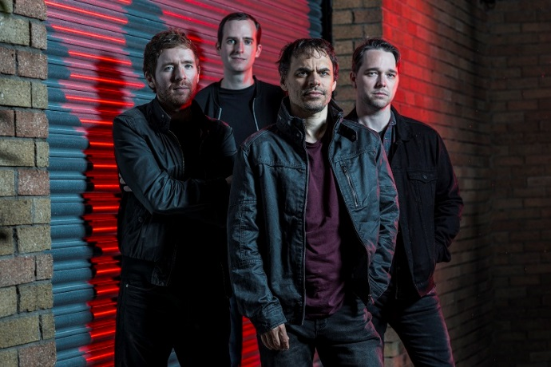
(photo credit – Eleanor Jane)

GODSTICKS – PREMIERE NEW TRACK & VIDEO FOR “SURRENDER”
TAKEN FROM THEIR FORTHCOMING NEW ALBUM INESCAPABLE

With the new and most accomplished album to date Inescapable due out on 7th February, Godsticks present their second single and video “Surrender”.

Watch the video for “Surrender” here

Godsticks’ Darran Charles divulges his inspiration for the song “I suppose Surrender is a lyrical re-enactment of conversations I’ve had with myself about not surrendering to the obsessive and controlling parts of my personality. I used to believe that my obsession to ‘achieve’ at all costs was both the key to success and the fuel for ambition but as the years went by, I found that I’d become so focused on achieving goals that I forgot the reasons I’d set them. A good example of this is playing live: I used to be so obsessed with being able to perform a perfect rendition of every song each night, that I forgot to be in the moment and enjoy the experience.
Eventually I realised I wasn’t enjoying anything and found myself belittling accomplishments, big or small. Even though I wanted to change, deep down there was this fear that if I diluted these strong aspects of my persona then I’d lose the drive and focus to improve. Over time I’ve learnt to control the obsession as much as possible by accepting that if I continue to work hard then it is ok to enjoy the fruits of my labour. This ongoing process of learning how to appreciate achievements and realising how lucky I am to be able to write songs that people might want to hear, has allowed me to enjoy music and therefore life. It is an ongoing challenge to reconcile those contrasting parts of my being, and in that sense the music of ‘Surrender’ is quite representative of me in that it’s in equal measure dark and uplifting!”
Godsticks’ mix of heavy rock, progressive and alternative metal with a dynamic range of angular riffs and emotional depth will leave listeners reeling and with Inescapable, the band have channelled their energy and technical ability into the melody, phrasing and vocal performance, allowing emotion to take centre stage.

The band found themselves wanting a definitive theme running through Inescapable, without turning it into a concept album, of being more open, more personal and ultimately one that shines an inquisitive light on Charles’s struggle with inner demons which gave the songs a new level of intimacy. “Lyrically, I’ve always shared personal thoughts, feelings and experiences but in a very ambiguous way. For Inescapable - in a conscious effort not to repeat ourselves – I thought I’d be a little more self-reflective and perhaps examine some of my inner demons. I have a strange relationship with music, and especially playing guitar. I would struggle to survive without either, but equally they have made my life mentally torturous because my own self-worth is completely wrapped up in them. I used to be very much a perfectionist in my early years, and whilst some people may wear that as a badge of honour, I eventually viewed it as huge heavy weight dragging down. It was a long time before I arrived at the realisation that perfection was impossible to achieve.” elaborates Darran Charles.

Inescapable was produced by James Loughrey (Skindred) and recorded at the famed heritage Monnow Valley studio.
Godsticks are supporting the new material beginning in April with a UK tour followed by summer festivals
2/4/2020 - Cardiff - Fuel Rock Club
3/4/2020 - London - Black Heart
4/4/2020 - Edinburgh - Opium
5/4/2020 - Manchester - Gullivers
Tickets available https://www.facebook.com/godsticks/
Inescapable will be released on CD, LP & digitally on 7th February through Kscope and is available to PRE-ORDER HERE NOW (“Denigrate” is available as an instant download on digital pre-orders – “Surrender” will be available on 31st January)
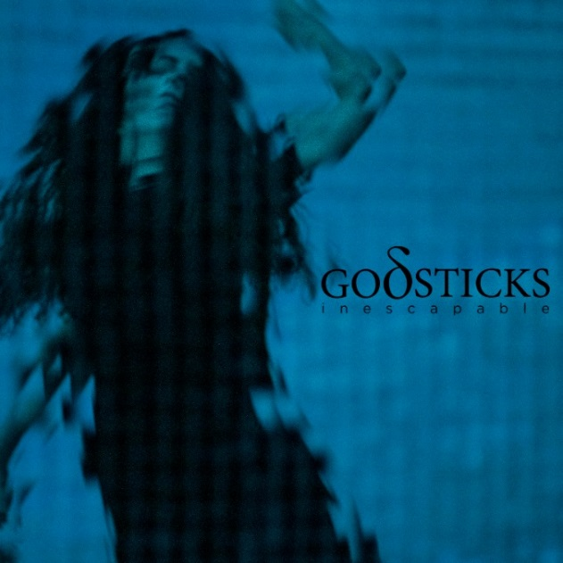 | Inescapable Tracklisting  1. Denigrate [03:53] WATCH VIDEO  2. Victim [06:14]  3. Relief [05:40]  4. Surrender [04:44]  5. Numb [05:08]  6. Change [09:31]  7. Breathe [05:17]  8. Time [05:48]  9. Resist [04:36]

Godsticks are:
Darran Charles: Vocals, guitars, keys, synths
Dan Nelson: Bass
Gavin Bushell: Guitars
Tom Price: Drums
Backing vocals on ‘Denigrate’ – Daniel Tompkins

Follow Godsticks:
Website: www.godsticks.co.uk
Facebook: https://www.facebook.com/godsticks/
Instagram: https://www.instagram.com/godsticksmusic/
Twitter: https://twitter.com/Godsticks
YouTube: https://www.youtube.com/user/godsticksmusic
Electronic Press Kit: http://www.godsticks.co.uk/epk

