GODSTICKS ANNOUNCE ALBUM
‘THIS IS WHAT A WINNER LOOKS LIKE’ OUT VIA KSCOPE ON MAY 26th
PREMIERE SINGLE ‘MAYHEM’

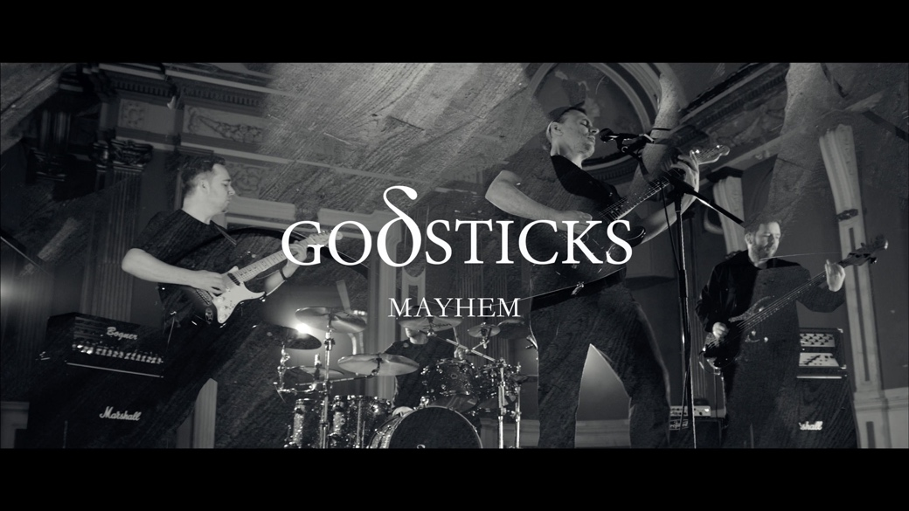

Preorder the album HERE (https://godsticks.lnk.to/winner)
Watch the video HERE (https://youtu.be/pIgO3bQqoBs)

Godsticks announce their return with their new album ‘This Is What A Winner Looks Like’ out May 26th via Kscope.

Introducing the new era of the band is single ‘Mayhem’. Musically the track flits from pneumatic staccato style riffs to an earworm chorus before an inspired solo slingshots us home to the song’s abrupt end. The track comes as the first taster of what ‘This Is What A Winner Looks Like’, an album that capitalises on the band’s near limitless sense of creativity, expert musicianship and effortless song writing to deliver what is surely their finest release to date.

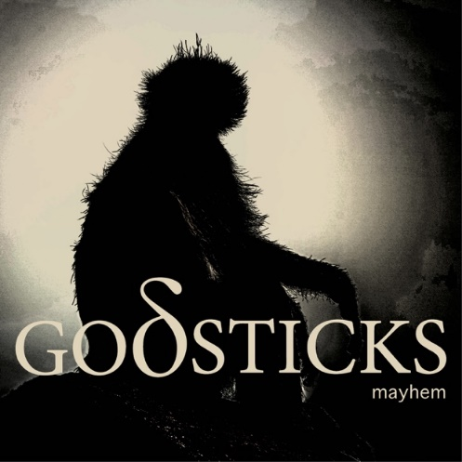

Characterised by a rhythmic groove, the song is a testament to the airtight playing of the band and their unorthodox song writing that has made them one of Kscope’s shining lights. A fantastic initial offering of what is to come from the next chapter in the story of Godsticks.

Revelling in the chaos of the track, Godsticks guitarist Darran Charles, had the following to say:

“I stumbled upon this really ugly dissonant chord that sounded great with distortion, and thought about ways of making it sound even nastier and more chaotic (hence the title). But I was also interested in causing Tom (drummer) physical harm so I devised a bass drum pattern so complex that it will likely cause him a repetitive strain injury in the very near future. This song promises to be immense live and the music video hopefully translates the energy we’re going to bring to the stage when we take this song out on the road.”

Accompanying the song comes a video, produced by Martin Holmes (@ohmzfilm on Instagram), which brings this musical dissonance to life and has its own story to tell as Charles illustrates below:

“For what is probably the heaviest and most rebellious track on the forthcoming album ‘This Is What A Winner Looks Like’ we chose a location that itself was the location of the last large-scale armed rebellion against authority in Great Britain – The Westgate Hotel. Where on the 4 November 1839, local politician and activist John Frost led a protest march of 3,000 Chartists, some of them armed, into the centre of Newport, South Wales. Godsticks – as of yet – have no plans to form such a rebellion.”

Having released ‘Inescapable’ in February 2020, a mere month before the world plummeted into lockdown, the band had no means to perform the new songs to an audience. Living in this world of stasis, it wasn’t until September 2021 when the band were able to perform the tracks for a live audience that they began to think about their next album.

“It was impossible not to notice the creative tsunami that the pandemic engendered in the music industry – every band and their dog were writing and releasing new music. For me though, it was the least creative time in my entire life.” mentions Charles.

Their love for writing and productivity had been reignited simply by being able to perform live. Despite the new found resolve, the band remain humble yet incredibly driven. Experimenting with electronic sounds and delegating writing duties in the band allowed ‘This Is What A Winner Looks Like’ to be their most collaborative album to date.

Recorded at the legendary Rockfield Studios, the album was produced by James Loughrey and mastered by Maor Appelbaum. The album’s striking cover artwork was created by Richard Beeching who mentions “The band and I agreed we needed a visually engaging sleeve to match the album’s strong title, but nothing too literal. Something just about abstract enough to allow the audience to make of it what they will. Our primate fits the bill nicely.”

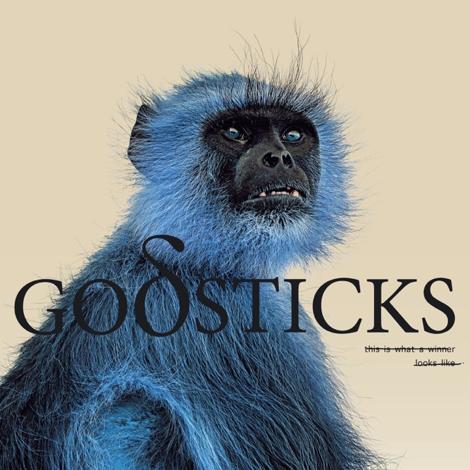

Godsticks – ‘This Is What A Winner Looks Like’

- If I Don’t Take It All
- Eliminate and Repair
- This Is My New Normal
- Devotion Made To Offend
- Silent Saw
- Throne
- Don’t Say A Word To Me
- Mayhem
- Lying
- Wake Up

The album will be available in the following formats:

LP – Black vinyl
CD – Digipak
Digital

Pre-orders from the band’s store get a bonus 3 track CD titled ‘Crushed’ and pre-orders from Kscope store will also receive the bonus 3 track CD as well as a signed postcard.

Pre-order here: https://godsticks.lnk.to/winner

The band will be appearing live for the following dates with more to be announced soon!

Godsticks live

22nd June – Cardiff – Fuel
23rd June – London – Camden Assembly
24th June – Newcastle, The Cluny 2
25th June – Edinburgh – Legends

Pick up tickets here https://www.godsticks.co.uk/gigs

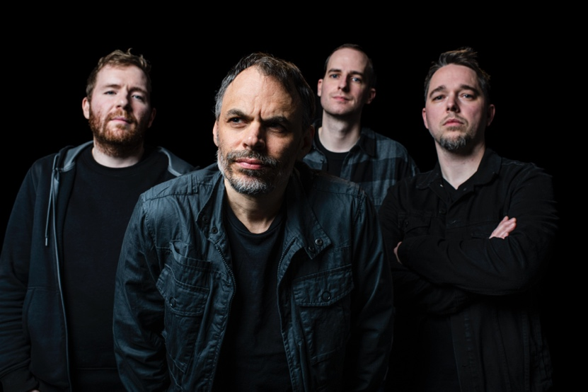
Photo credit: Eleanor Jane

GODSTICKS online

Website - https://kscopemusic.com/artists/godsticks/
Facebook - https://www.facebook.com/godsticks
Instagram - https://www.instagram.com/godsticksmusic/
Twitter - https://twitter.com/godsticks
YouTube: https://www.youtube.com/user/godsticksmusic

